Required Practical Activity:
Determination of the reacting volumes of solutions of a strong acid and a strong alkali by titration.

Note:
This resource is designed as a review of the required practical activity, covering all possible skills that could be developed through the investigation. This resource can be adapted to suit the needs of your class, depending on which skills your class need support with.

In this experiment we will use a burette and colour-changing indicator to find the reacting volumes of solutions of a strong acid and alkali.
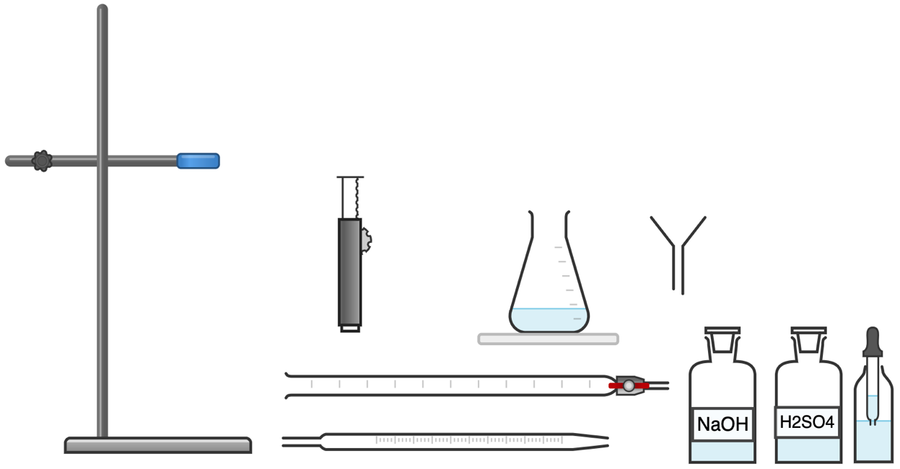
(Phenolphthalein)
Equipment Per Group

- Variables
- What is the independent variable? | The volume of the titrant (sulfuric acid).
- What is the dependent variable? | The volume of the sodium hydroxide.
- What are suitable control variables? | The concentration of the sodium hydroxide, the amount of indicator added, the use of a white tile as a reference, the amount of stirring during titration.
- Equipment:
- What measurements need to be taken in this investigation? | The volume of sodium hydroxide in the conical flask, the volume of sulfuric acid added to the sodium hydroxide, the pH of the solution.
- What is the most suitable piece of apparatus to take these measurements with? Why? | A glass pipette is an accurate way of measuring the volume of sodium hydroxide.  A burette allows us to slowly add sulfuric acid to the sodium hydroxide while measuring how much has been added.  Phenolphthalein indicator will change colour at the exact moment of pH 7.
- Identify any hazards in this investigation. | Sulfuric acid and sodium hydroxide are both classed as irritants.  Pouring solutions above head height is hazardous as a spill or a splash could result in a harmful chemical getting in somebody’s face.
- How can we minimise these hazards? | Take care with all solutions and move the burette to the floor before filling it.
- Why is it important to remove the funnel from the burette before carrying out the titration? | Extra solution may drip from the funnel into the burette and introduce an error into the results.
- How do you read the scale of the burette? | Read the scale from the bottom of the meniscus of the liquid.
- Why do we read the burette in this way? | To ensure consistency between readings and because it is the most accurate reflection of the true level of the liquid (the sides of the meniscus are elevated due to surface tension at the very edge of the liquid).
- Why do we constantly swirl the conical flask? | To ensure all of the solution has reacted.
- Why do we use a white tile beneath the conical flask? | To best see the colour change of the solution.
- Why do we add the solution from the burette slowly? | So as to not miss the exact point at which the solution in the conical flask is neutralised.
- What colour change does the phenolphthalein indicator exhibit? | It goes from a transparent appearance when neutral or acidic to purple when alkaline.

4. Results
Attempt | Volume of sulfuric acid added to neutralise the 0.1 mol/dm³ sodium hydroxide (cm³)
1 | 16.3
2 | 15.7
3 | 15.5
Mean (from concordant results) | 15.6

- Why do we run numerous titrations and take the mean result? | To minimise the effect of human error or anomalous results.
- Why is the first result most likely to be inaccurate? | Because during the first titration, the end point was unknown. For subsequent titrations, the student had a rough idea of when to slow down and start titrating drop-wise and therefore was able to achieve a more accurate result.
- Why do we only calculate the mean from concordant results? | The first result is most likely to be anomalous due to the reasons explained above. Calculating the mean from just the concordant results is more likely to give us an accurate result.
- What was the mean volume of sulfuric acid added to neutralise the sodium hydroxide? | 15.6 cm³
- What is the balanced equation for this reaction? | 2NaOH(aq) + H₂SO₄(aq) → Na₂SO₄(aq) + 2H₂O(l)
- What is the mole ratio of NaOH:H₂SO₄? | 2:1
- Calculate the concentration of the sulfuric acid. | 0.08 mol/dm³

